# Kotini Sai Madhuhas
#2024.02.03
#numbers examples
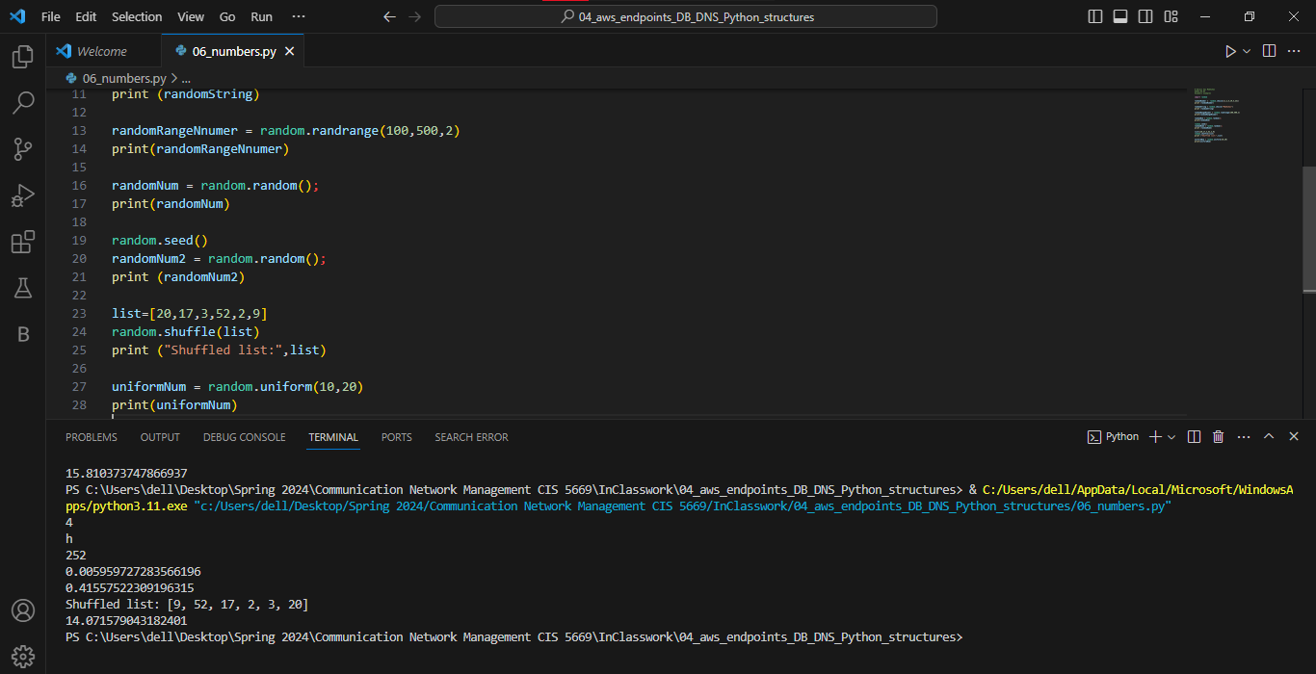

#string examples
